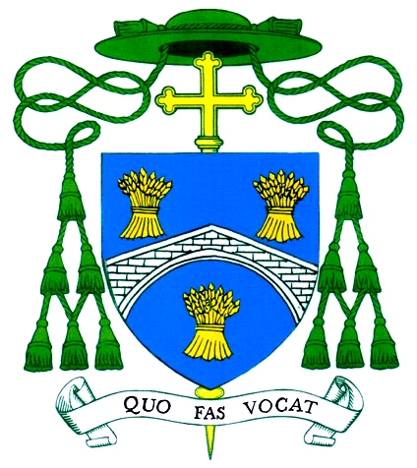
DIOCESE OF SALFORD

Pastoral Letter of the
Right Reverend John Arnold
Bishop of Salford

To be read and circulated on the weekend of 16th/17th January 2021

Dear Brothers and Sisters in Christ,

In the first place, I would like to wish you all a Hope-filled, happier and healthier New Year; one in which we may rise to the challenges and opportunities of our response to the pandemic, renewing those Gospel values which will make us more attentive to the needs of our brothers and sisters, our global family, and care for our common home. I do believe that there are important choices to be considered, in which we will all have our part to play. Today, I am writing to you about two important, and connected, matters.

The final Sunday of this month, January 31st, is dedicated, in this Diocese, to the work of Caritas Diocese of Salford. You may well be familiar with at least some of the wide range of work and projects that are undertaken by Caritas. Its whole focus of activity is the commitment of putting Faith into action by responding to emergencies, helping people to transform their lives and emerge from poverty in all its forms, and advocating change in our society so that everyone may live with dignity, in a sustainable way.

There is much work to be done. While we live in the sixth wealthiest nation, the statistics indicate that all too many people are not included in this prosperity. For example, there are 70-80 people sleeping on the streets in central Manchester every night, while many families are in inadequate and temporary housing, vulnerable to eviction. A recent government survey estimated that over one million people in this country are isolated and alone, even before the pandemic arrived. Isolation and loneliness lead to depression and mental illness. Even the increasing adoption of the real living wage still means that many families, even where the adults are employed, do not have adequate resources to provide healthy food for their children. All too many people are marginalised as if, as Pope Francis says, they have been “thrown away”

Our Faith has a very practical priority. We are asked to love our neighbours as ourselves and that love must include a constant care for the well-being of others. There should be no need for foodbanks and night shelters but, while ever there is the need, we as Christians must strive to provide them.

The Covid pandemic has caused so much more poverty, unemployment, and distress but I believe that we have every good reason to be proud of the work of Caritas and its diverse engagement in the social problems of our times. Caritas has been able, because of your generosity, to continue its services throughout this difficult time. Thank you for all that you have done, by generous giving and volunteering, to make Caritas all that it is today. I can only ask that this good work is enabled to continue so that no-one is beyond reach and no-one is marginalised or left behind. Your gift in the retiring collection on Caritas Sunday is even more important in these difficult times.

My second reason for writing to you concerns our preparation for the future. Since my arrival in Salford, in 2014, we have carried out a re-structuring of parishes which has been mainly due to the reduction in the number of priests, and the diminishing of large Catholic communities. Now we must look carefully at the way we must expect our parishes to flourish in the increasing secularisation of the times in which we live. Given the disruption to parish life over the last year, we have also to consider carefully how best we organise our sacramental programmes and the preparation and celebration of Baptisms, First Reconciliation, First Holy Communion and Confirmation during these days of pandemic.

I have asked Fr Paul Daly, the Episcopal Vicar for Formation, to extend his role, both in planning for our immediate needs in sacramental provision and for developing our various adult formation programmes which will be essential in our “Journey to 2030” when our parishes will need to function in a very different way. Parishes will need to be increasingly reliant on the contribution of their parishioners in many and diverse ways. Fr Paul has agreed to relinquish his role as parish priest so as to be more available to assist others in developing parish formation. I am very grateful to him for his readiness to undertake this extended role which is initially intended for one year but may be extended according to need. Fr Paul will be working from Cathedral Centre and visiting parishes.

Despite the advent of vaccines, this time of pandemic will be with us for some time to come. Even with the gloom, anxiety, and frustration of living through these days, I am optimistic that we can set ourselves a new road, with better priorities for our Church and our nation and our world. I believe that much good can be achieved and we must remain adamant in our prayer, as we ask: “Stay with us, Lord, on our Journey”.

With my best wishes for all that lies ahead in this New Year and my thanks for all that is being achieved through your goodness and generosity.

+John Arnold
Bishop of Salford

Tel: 0161 794 2825
bishop@dioceseof salford.org.uk (bishop) marie.sartini@dioceseofsalford.org.uk (secretary)
Salford Roman Catholic Diocesan Trustees Registered Charity

